It’s time for the Annual Fall In-service for Agricultural Education Teachers.

The Department of Public Instruction, the Wisconsin Technical College System, and the Wisconsin Association of Agricultural Educators (WAAE) are partnering to sponsor this professional development opportunity.

This year the in-service meetings will include the following workshops:

- SAE for All
- Work-Based Learning and SAEs
- DPI Updates
- WAAE Sectional Meetings and Best Practice Sharing of Ideas
- Current Events in Agriculture

There is no registration fee
for participants.

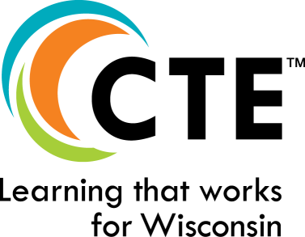
Agenda*

8:30 a.m. Registration/Coffee and Donuts
8:45 a.m. Host Welcome and Comments
9:00 a.m.
SAE for All – bringing it to your classroom
Explore techniques for incorporating SAEs in your classroom and finding ways to engage all students. SAE for All ensures all students have exposure to career ready skills needed to be successful beyond high school. Explore ways to ensure they are obtaining these skills.

10:15 a.m. Break
10:30 a.m.
DPI Updates – Work Based Learning
Dive into the components of a Work Based Learning experience and when SAEs can be counted as Work Based Learning for a school report card. Evaluate the work based learning opportunities that are available to agricultural education students.

12:00 p.m. Lunch/Sectional WAAE Meeting
(Lunch is at your own expense.)

1:30 p.m. Workshop
Current Events in Agriculture
The agriculture industry is constantly changing. As Agriculture Teachers it is vital to remain up to date on current events within the industry to ensure students are receiving the most relevant information and experiences possible. This time allows for teachers to explore current events in Agriculture through a variety of formats from tours to guest speakers and beyond.

3:30 p.m. Adjourn

*Times of presentations are subject to change to accommodate guest presenter

